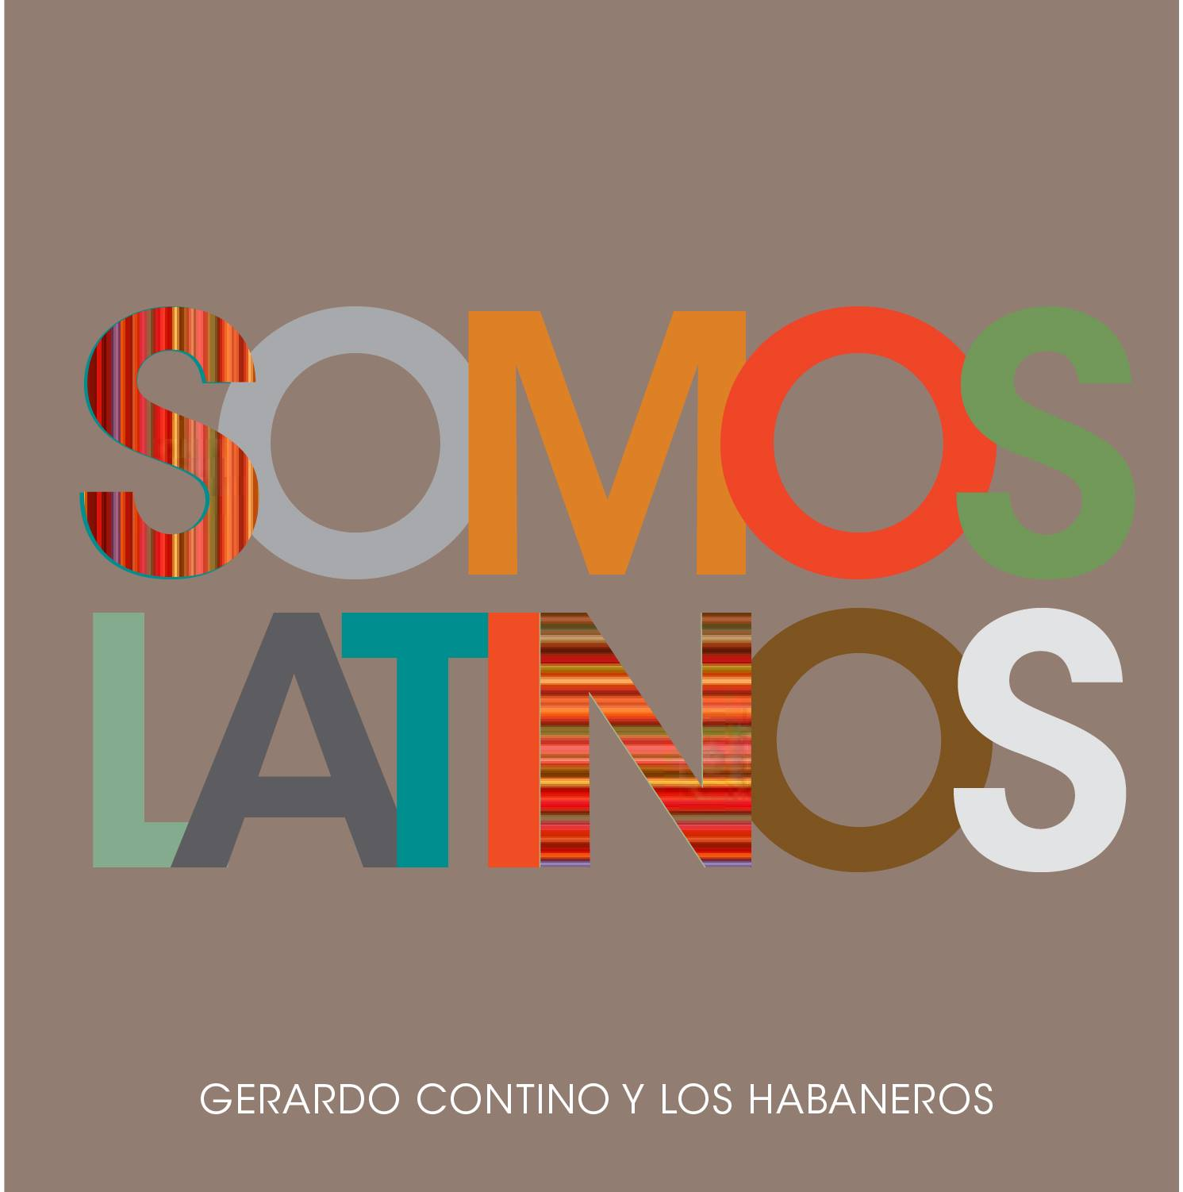
FOR IMMEDIATE RELEASE
347-722-1532
info@gerardocontino.com

Gerardo Contino y Los Habaneros
Release “Siempre Latino” Music Video

“a joyful, gyratory salsa celebration” – TimeOut New York

New York, NY – The newest generation of Cuban artists now residing in New York City, have teamed up to create the “Siempre Latino” music video by Gerardo Contino y Los Habaneros, an emerging salsa band composed of accomplished musicians. The video, directed by award-winning Cuban filmmaker, Tane Martinez, (Inti Martinez (Color), Gigi de la Torre (Foto) y Hensel Guerra (VFX)), is produced by Colorbox.tv, and features award-winning Cuban actress Annia Bu. The song, “Siempre Latino,” is an homage to the beauty of various Latin American cultures and their musical history. The video and band feature: five-time Grammy award winning bassist, John Benitez, Artistic Director Axel Tosca Laugart, Sebastian Nickoll, Marcos Lopez, Hommy Ramos, and Miki Hirose.

“This video brings together an incredible cross-section of a young generation of Cuban artists, from filmmakers, to actors, to musicians. Our idea for this video, as well as the album as a whole, was to offer a new, fresh sound,” says Gerardo Contino, lead singer and director of the band. “This song in particular was the first song I composed when I came to New York, as a tribute to the diversity of Latino culture in the city.”

“Siempre Latino” appears in the band’s debut album, “Somos Latinos,” produced by Luisito Quintero, and featuring Roberto Quintero, arrangements by Oriente Lopez, and Efrain Davila, and guest vocalist Xiomara Laugart, the “voice of Cuba.” The album was recorded and mixed in Skylight Studio by Grammy-award winning sound engineer, Guido Diaz.

The band has upcoming shows in New York (Gonzalez y Gonzalez, Seton Hall’s South Orange Performing Arts Center), as well as upcoming tours in Peru, Mexico, and Cuba.

Watch the Official Video of Siempre Latino - Watch Gerardo Contino perform @ BAM

For more info:
Website - Facebook - Twitter - YouTube

For more information, promo requests or to set up an interview, please contact us at 347-722-1532 and info@gerardocontino.com

###

